TC001: User able to create account using special symboll “@” in password field

BUG01: User not able to create account using special symboll “@” in password field

Steps:

1. Search Url in chrome driver
2. Insert Username
3. Insert Password
4. Click on login button

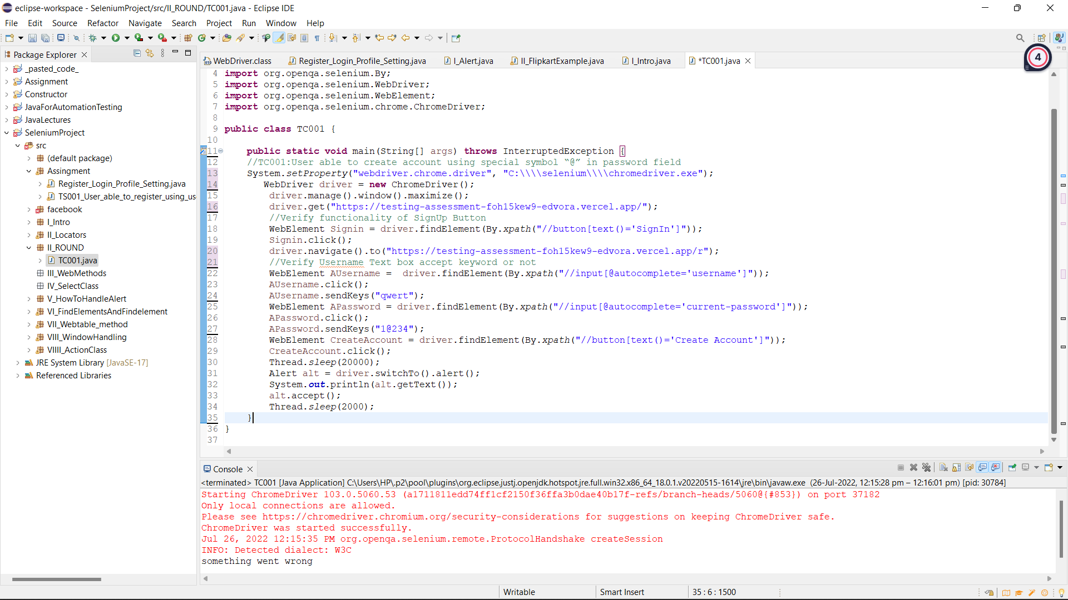

Observed Result: ‘Something went wrong’ message pop up on screen

Status: Fail

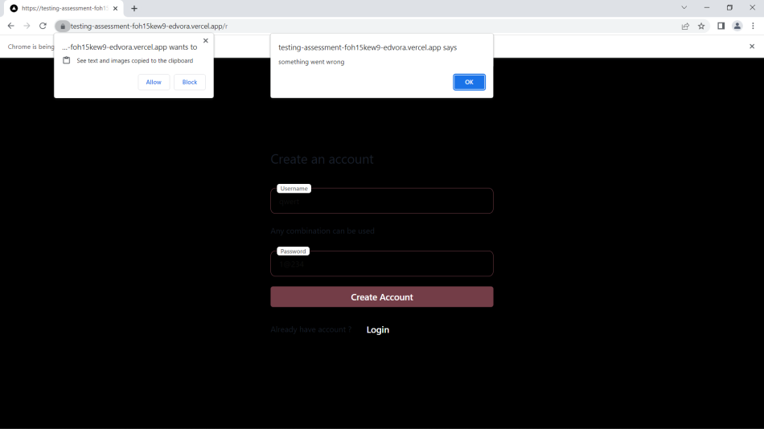

Expected Result: User able to create account using special symboll “@” in password field

Priority: High

Severity: High

TC002: User able to login after login after logging out consecutively

Status: Pass

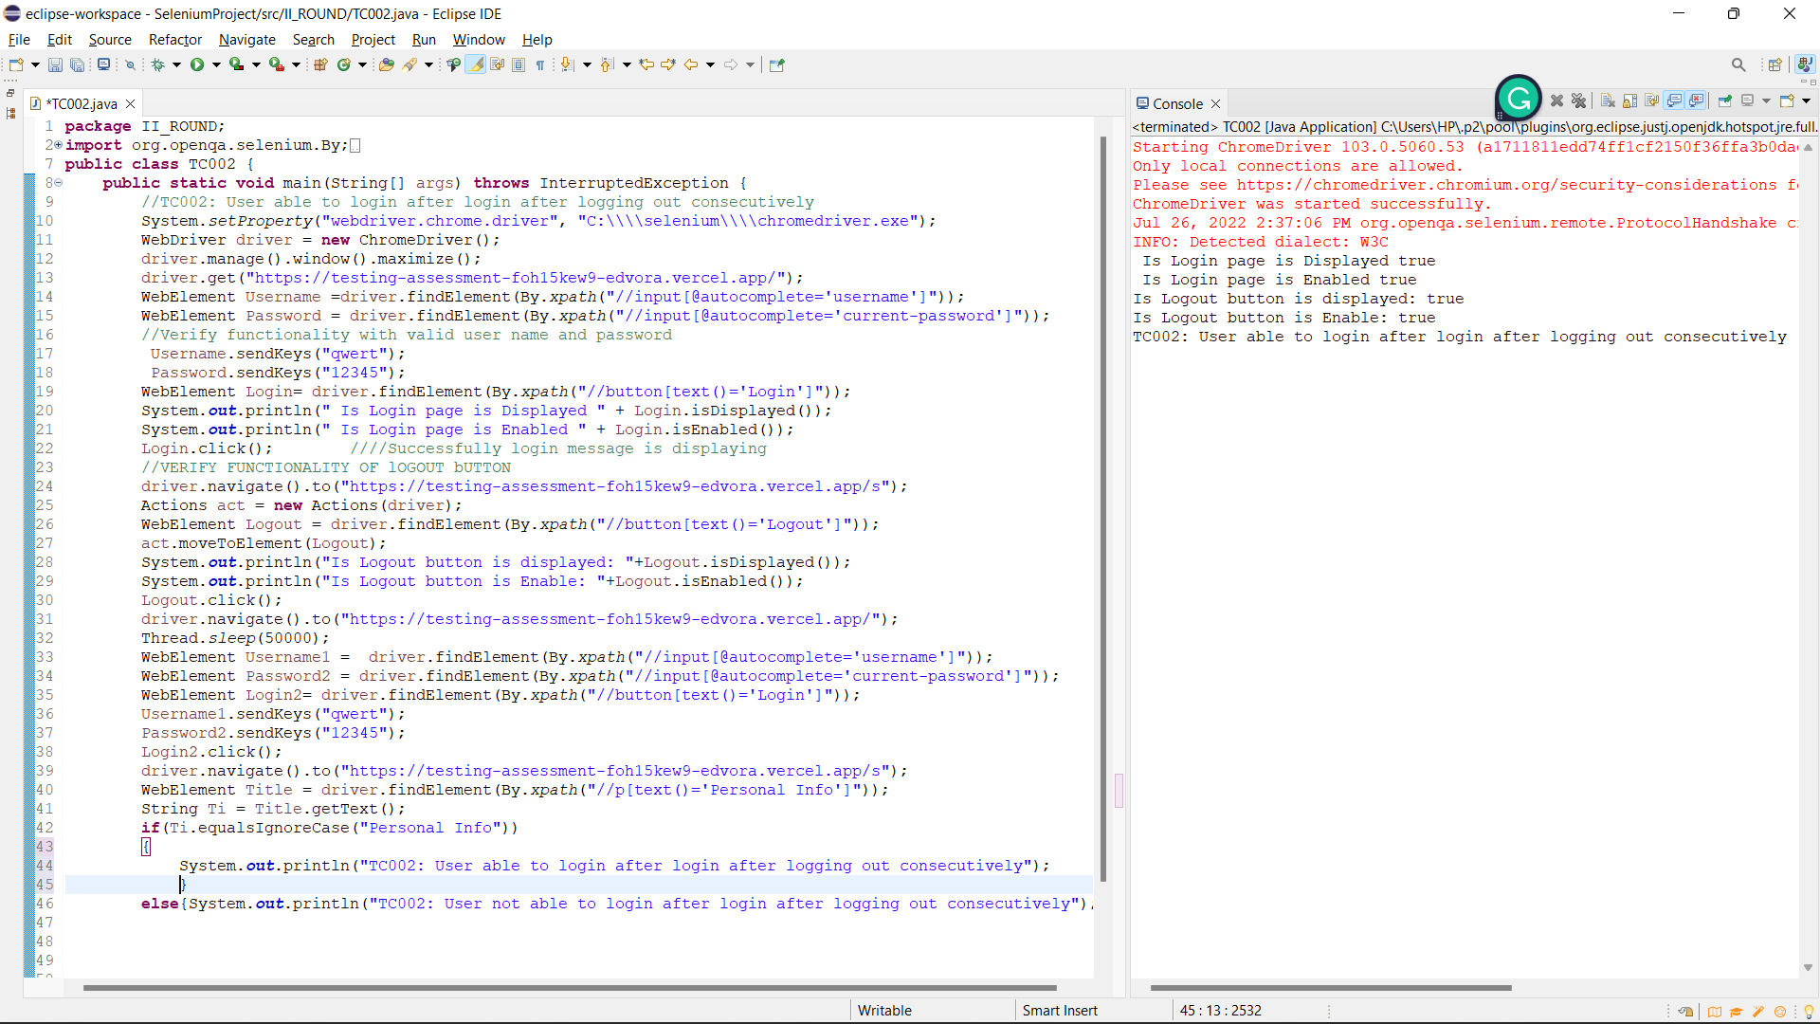

TC003: User able to change mobile no

BUG02: User not able to create account using special symboll “@” in password field

Steps:

1. Search Url in chrome driver
2. Insert valid Username
3. Insert valid Password
4. Click on login button
5. Click on Edit button
6. Enter Mobile Number
7. Click on save button
8. Click on Edit button
9. Clear previous Mobile Number
10. Enter Mobile Number
11. Click on save button

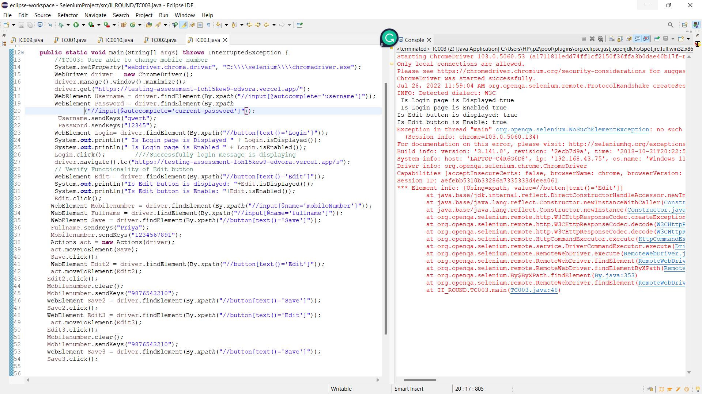

Observed Result: User unable to click on Save button

Status: Fail

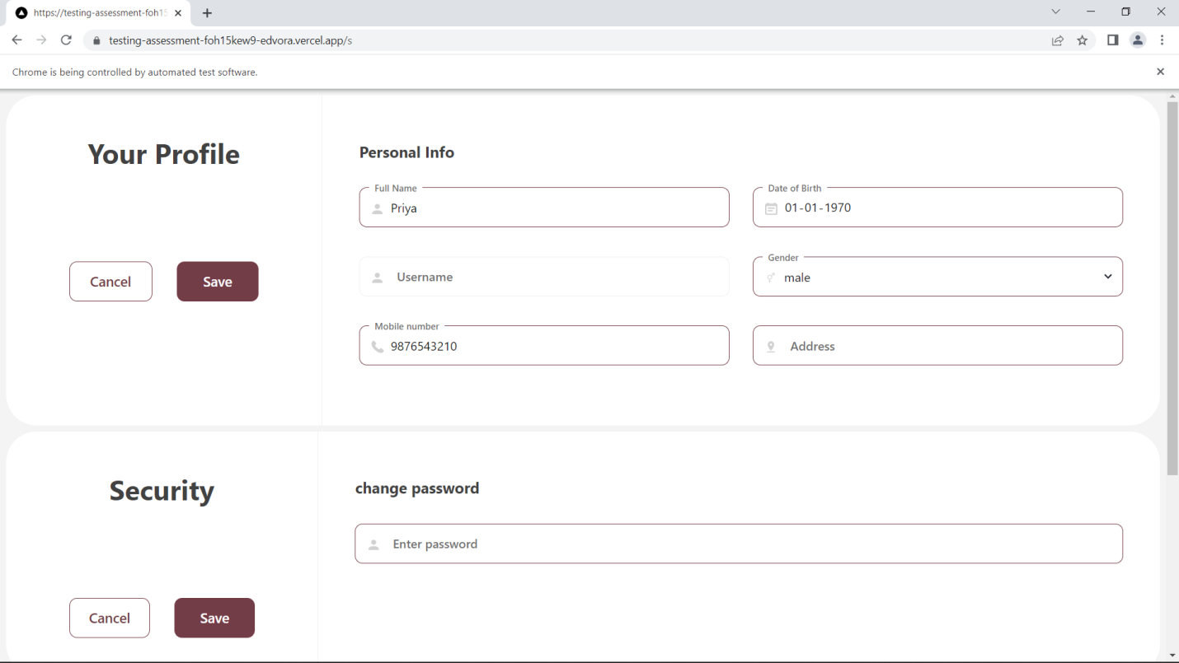

Priority: High

Severity: High

TC004: User able to give space in full name field inside setting page

BUG03: User not able to give space in full name field inside setting page

Steps:

1. Search Url in chrome driver
2. Insert Username
3. Insert Password
4. Click on login button
5. Insert full name

Observed Result:

Status: Fail

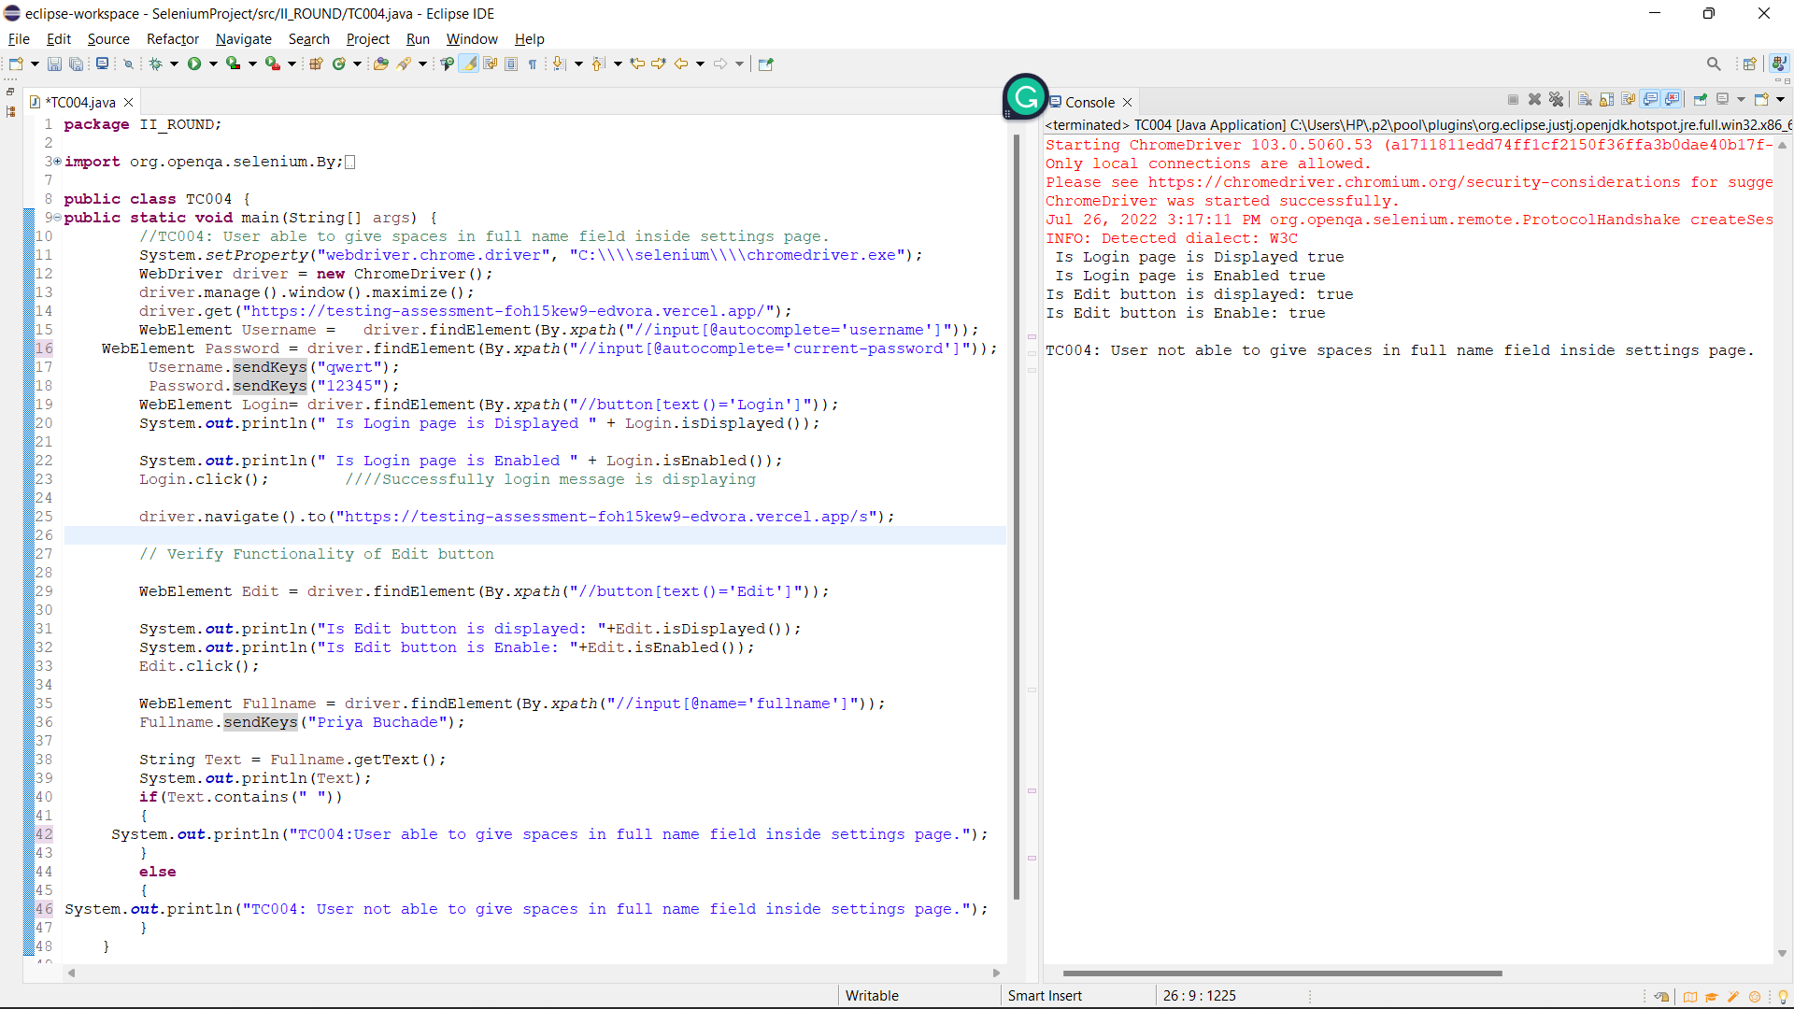

Expected Result: User able to give space in full name field inside setting page

Priority: High

Severity: Low

TC005: After registering an account , there should be native browser popup

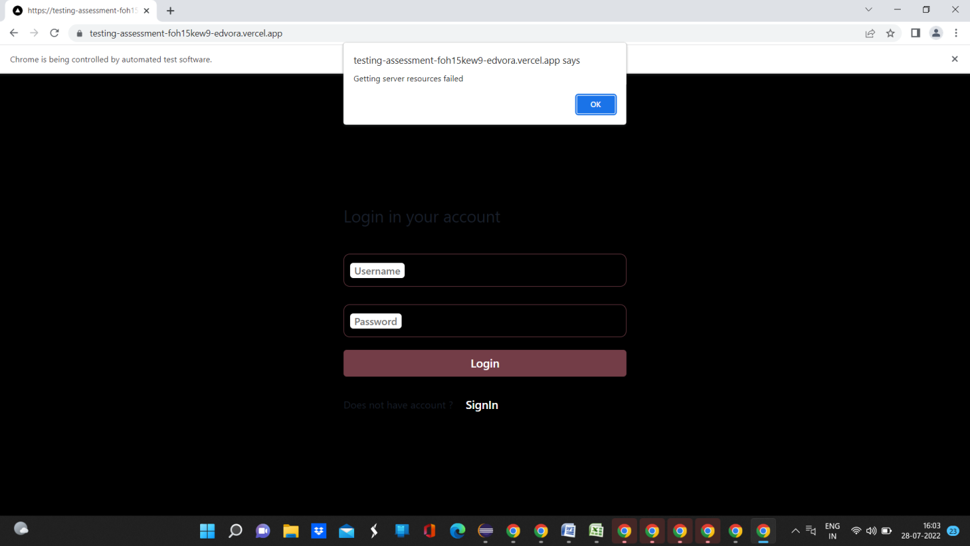

TC006: After registering an account , there should be native browser popup

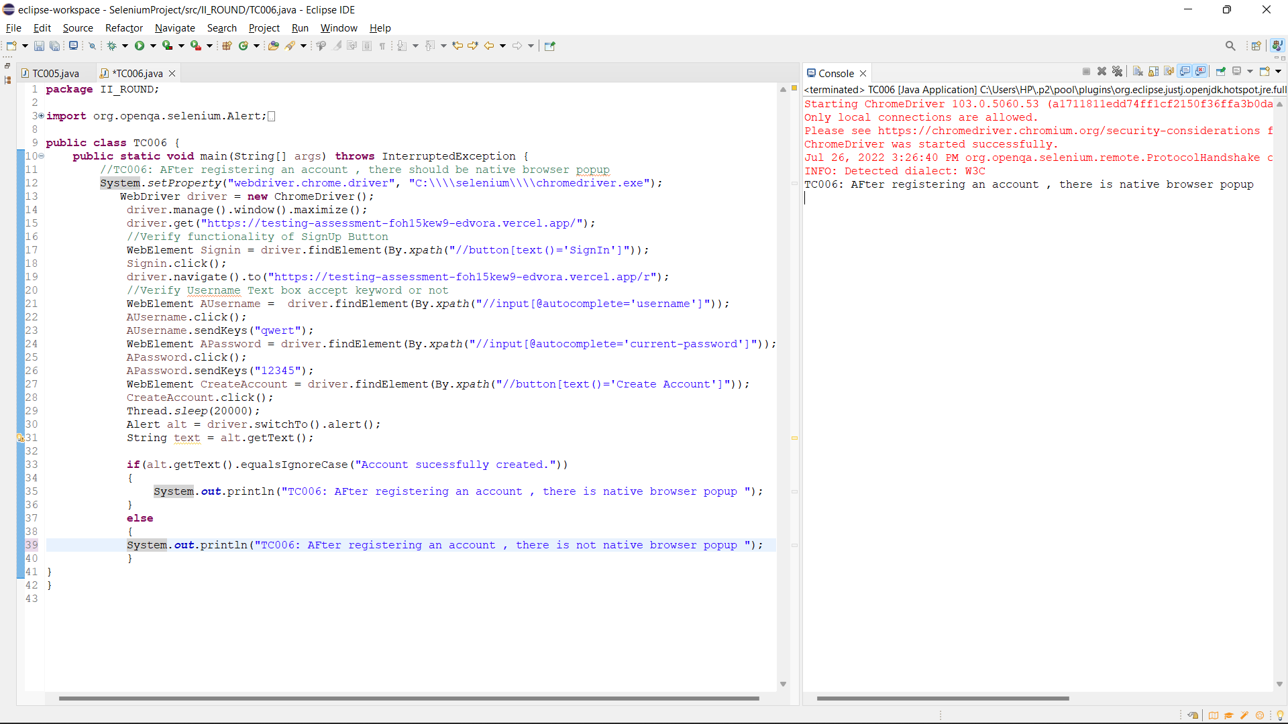

Observed Result: Pass

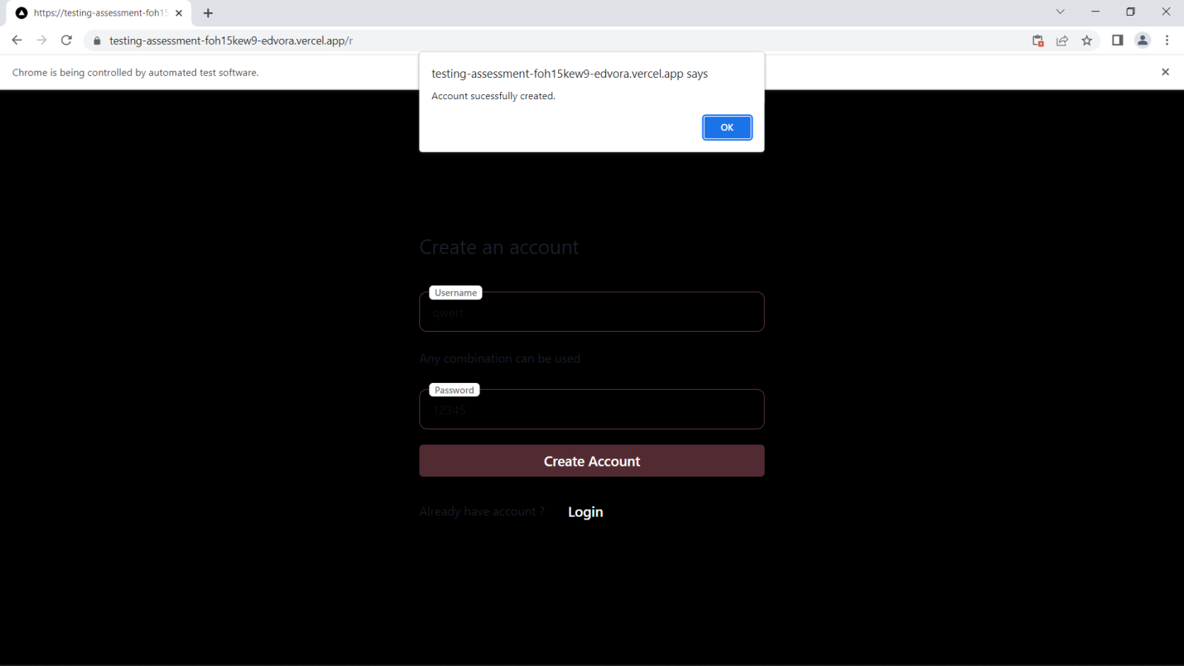

// TC007 User stays on the same page after registering .

Observed Result

Status: Pass

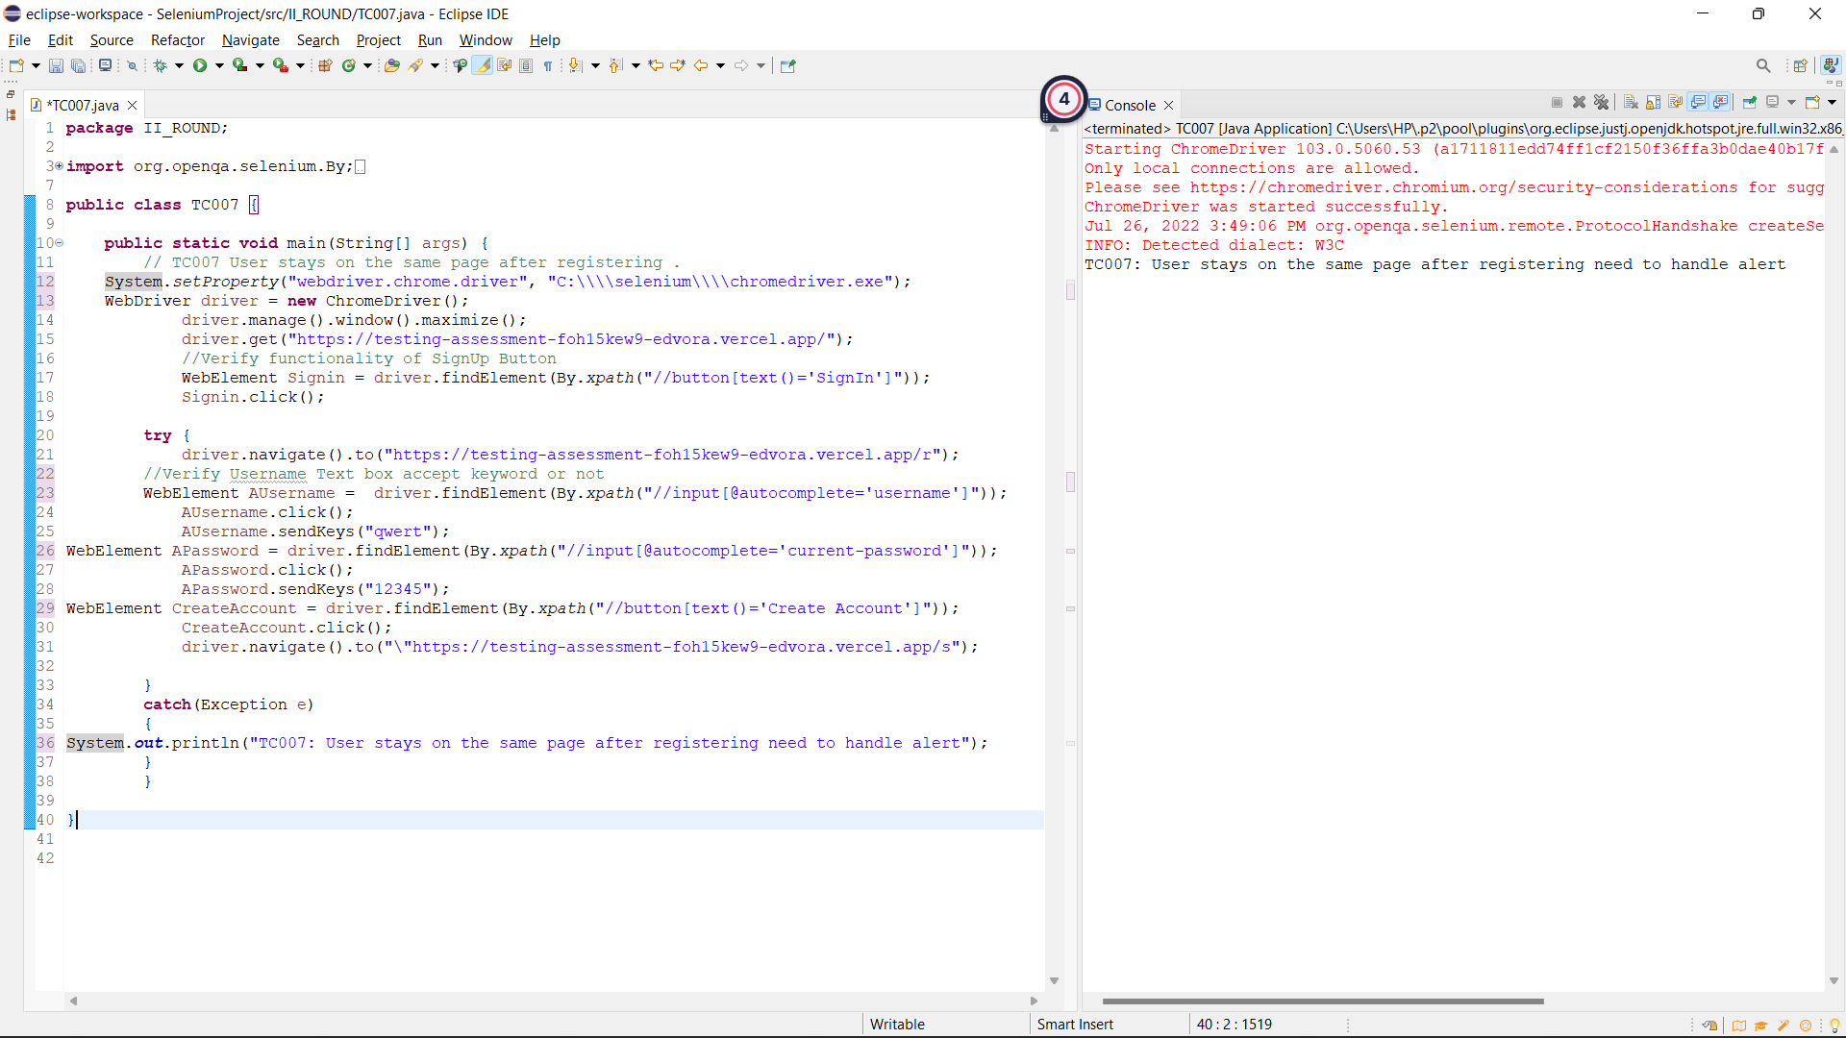

//TC008 User gets a native popup saying “Some went wrong” when user tries to login with invalid creds.

BUG04: User do not gets a native popup saying “Some went wrong” when user tries to login with invalid creds.

Steps:

1. Search Url in chrome driver
2. Insert Invalid Username
3. Insert Invalid Password
4. Click on login button

Observed Result: User do not gets a native popup saying “Some went wrong” when user tries to login with invalid creds.

Status: Fail

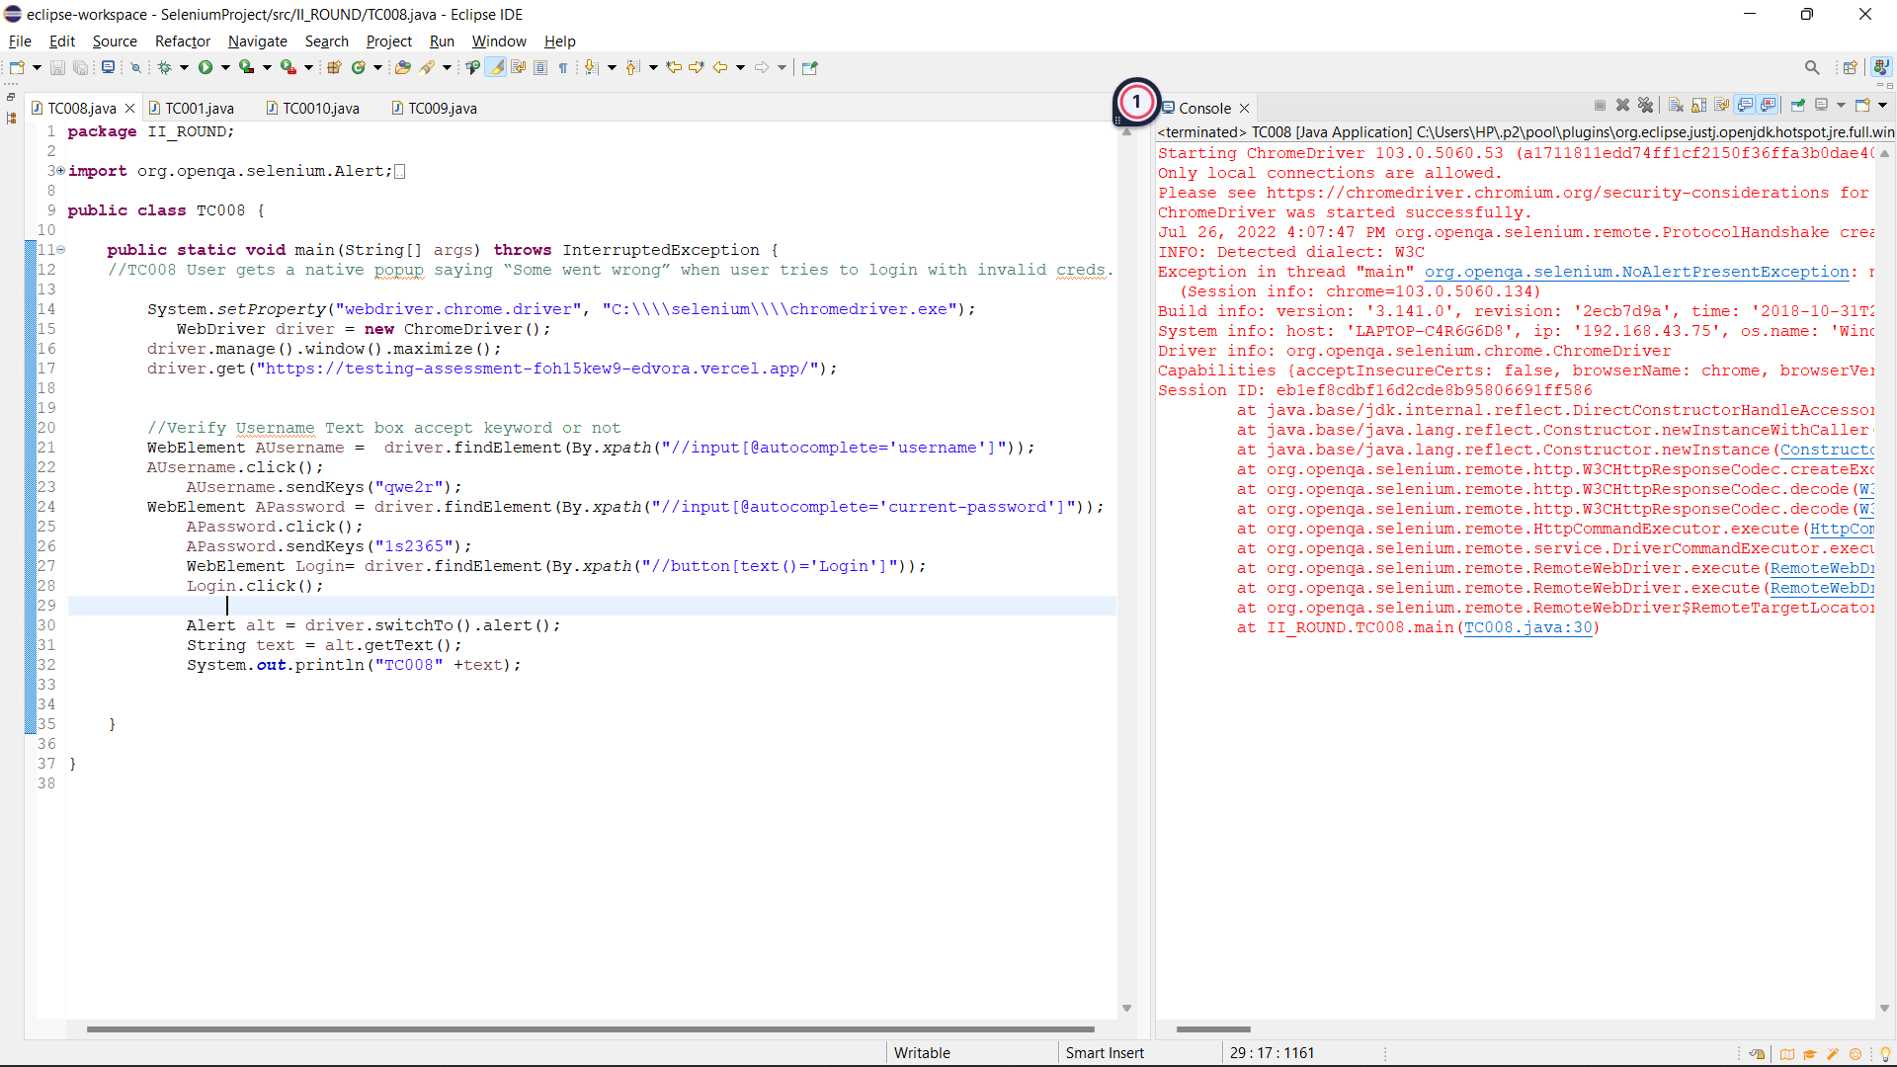

Expected Result: User gets a native popup saying “Some went wrong” when user tries to login with invalid creds.

Priority: High

Severity: High

// TC009: Users should not be able to open the settings page after logging out by using the url.

BUG05: Users able to open the settings page after logging out by using the url.

Steps:

1. Search Url in chrome driver
2. Insert Invalid Username
3. Insert Invalid Password
4. Click on login button
5. Click on logout button
6. Search setting page Url in chrome driver

Observed Result: Users able to open the settings page after logging out by using the url.

Status: Fail

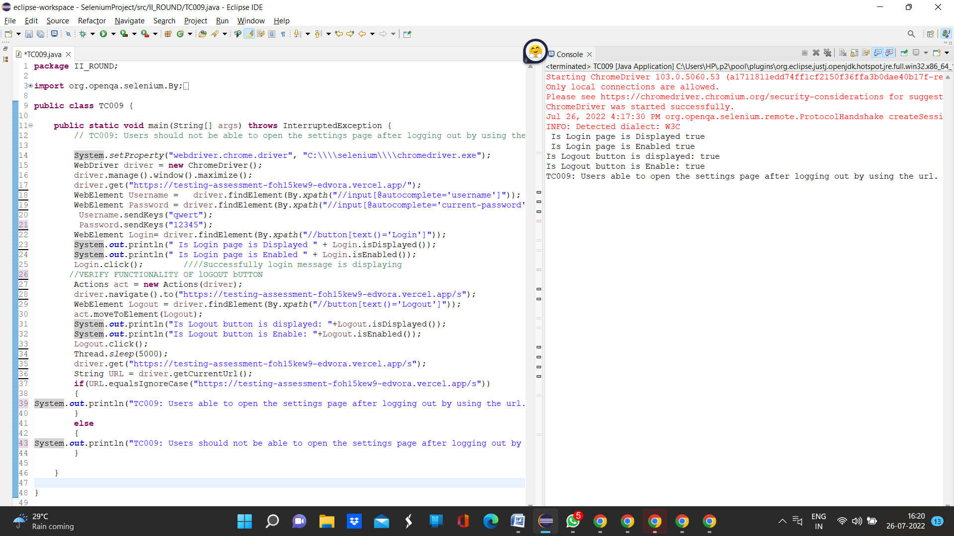

TC010: User able to go back after logging out using native browser back button.

BUG06: User not able to go back after logging out using native browser back button.

Steps:

1. Search Url in chrome driver
2. Insert Invalid Username
3. Insert Invalid Password
4. Click on login button
5. Click on backword arrow

Observed result

User not able to go back after logging out using native browser back button.

Staus: Fail

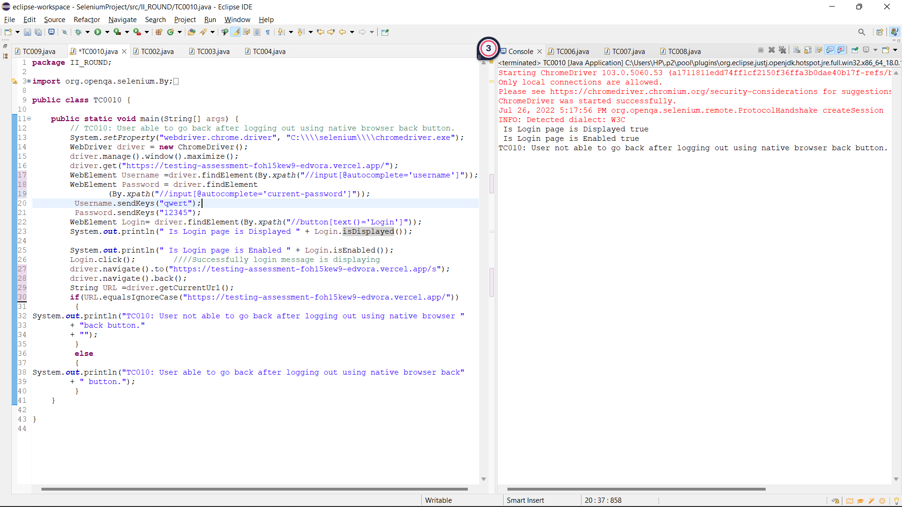

Extra Test cases

TC0011: User Should not able save mobile number is full name text box is empty and get Enter full name message

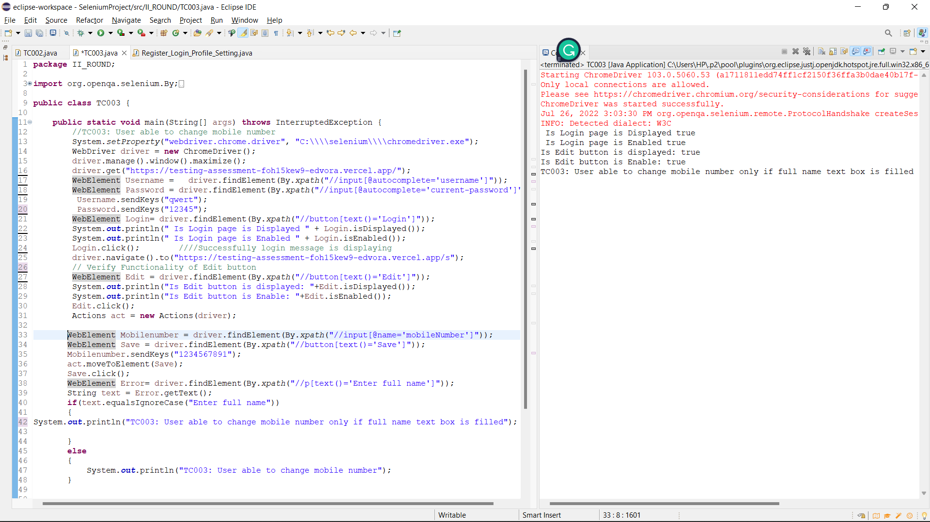

Observed Result: User Enter full name message below Full name text box

Status: Pass

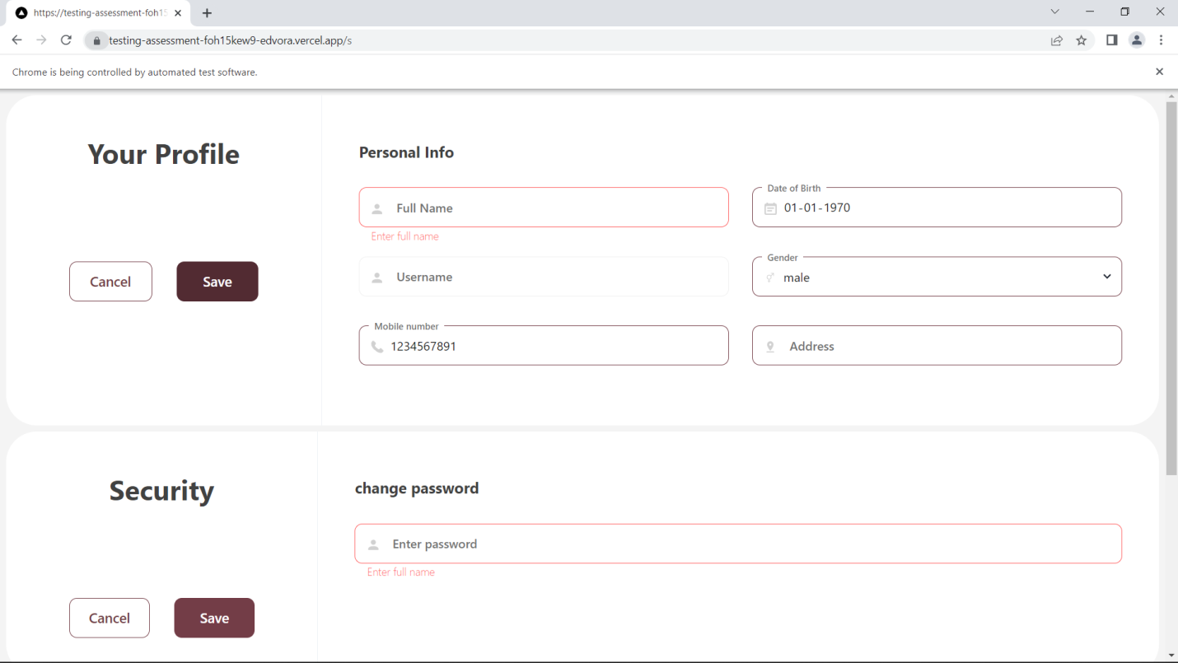

TC0012: User Should not able to go back to setting page after logout by clicking on backword navigation arrow

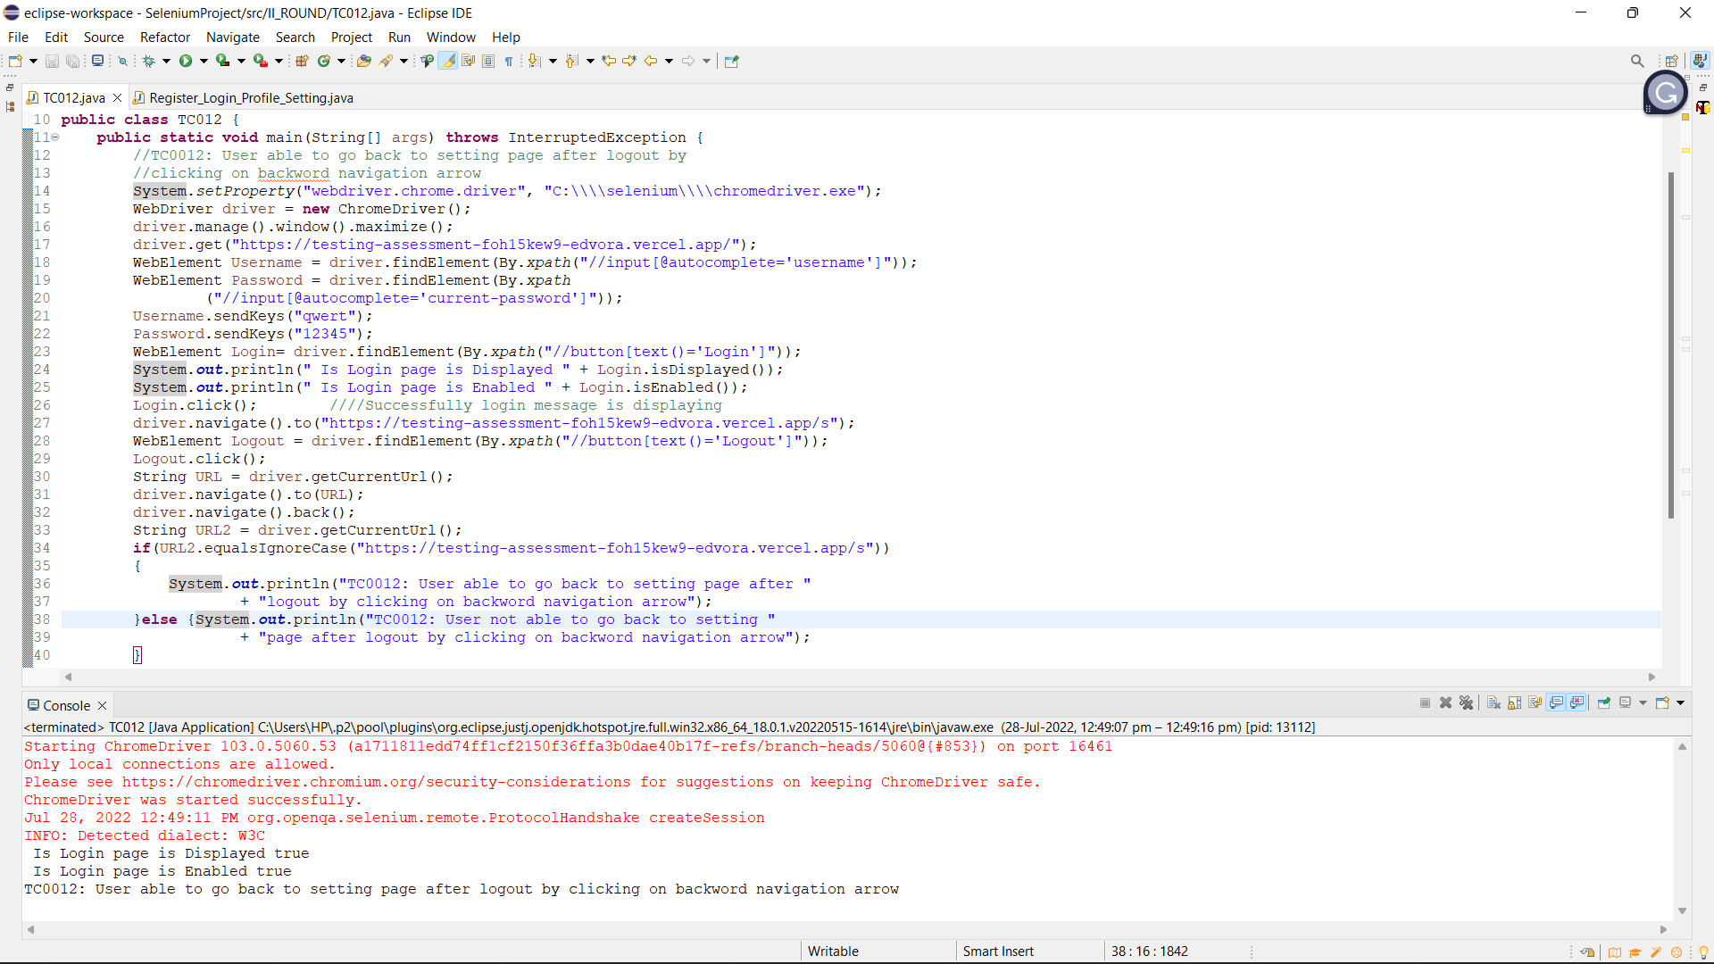

//TC0013:Text written in username and password text boxes should be of visible color

BUG07: User is not to see text entered in usename and password text box

Steps:

1. Search Url in chrome driver
2. Insert Username
3. Insert Password

Observed Result: User is not to see text entered in usename and password text box

Status: Fail

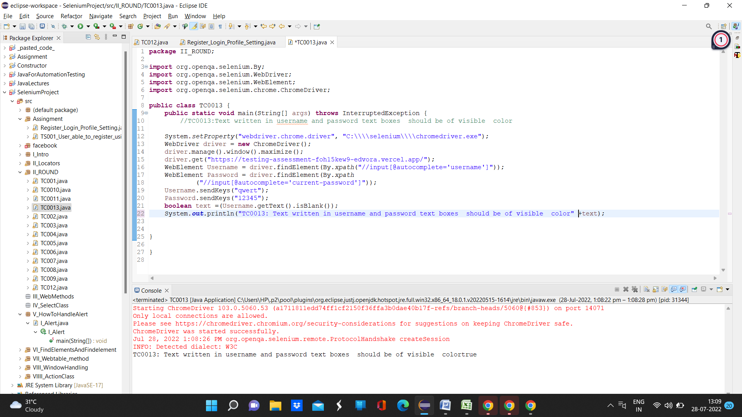

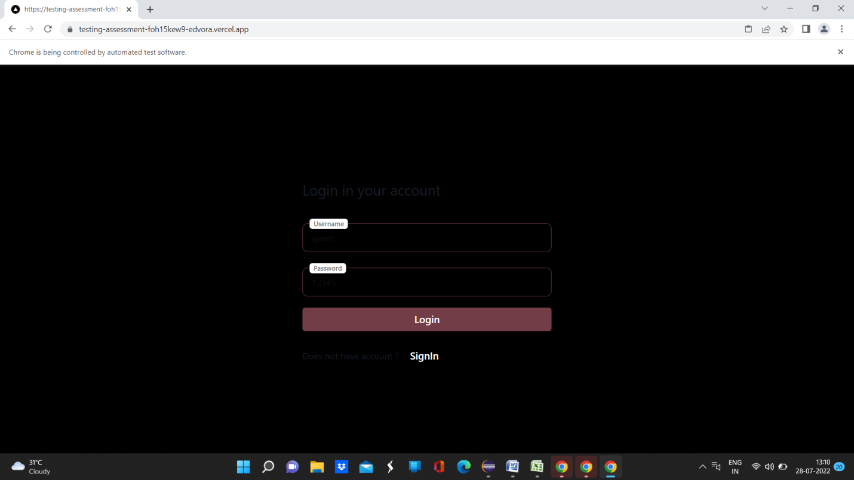  
Expected Result: User should able to read text entered in username and password textbox

Priority: High

Severity: High

//TC0014:Text written in username and password text boxes should be of visible color during SignIn

BUG08: User is not to see text entered in usename and password text box

Steps:

1. Search Url in chrome driver
2. Click on SignIn button
3. Insert Username
4. Insert Password

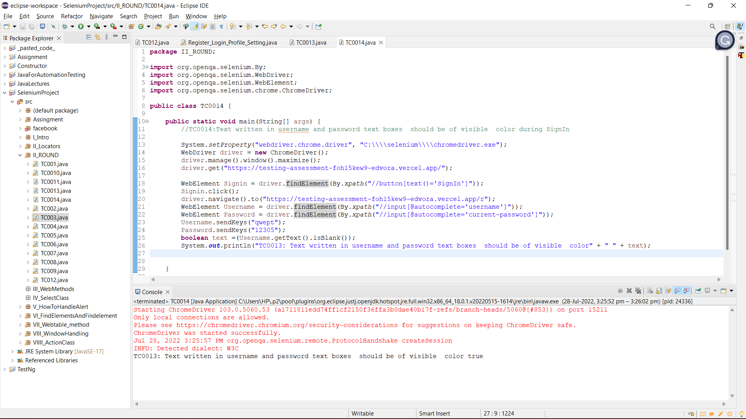

Expected Result: User should able to read text entered in username and password textbox

Priority: High

Severity: High

TC0015 User should not able to login with empty username

Status: Pass

Observed Result: User not able to login with empty username

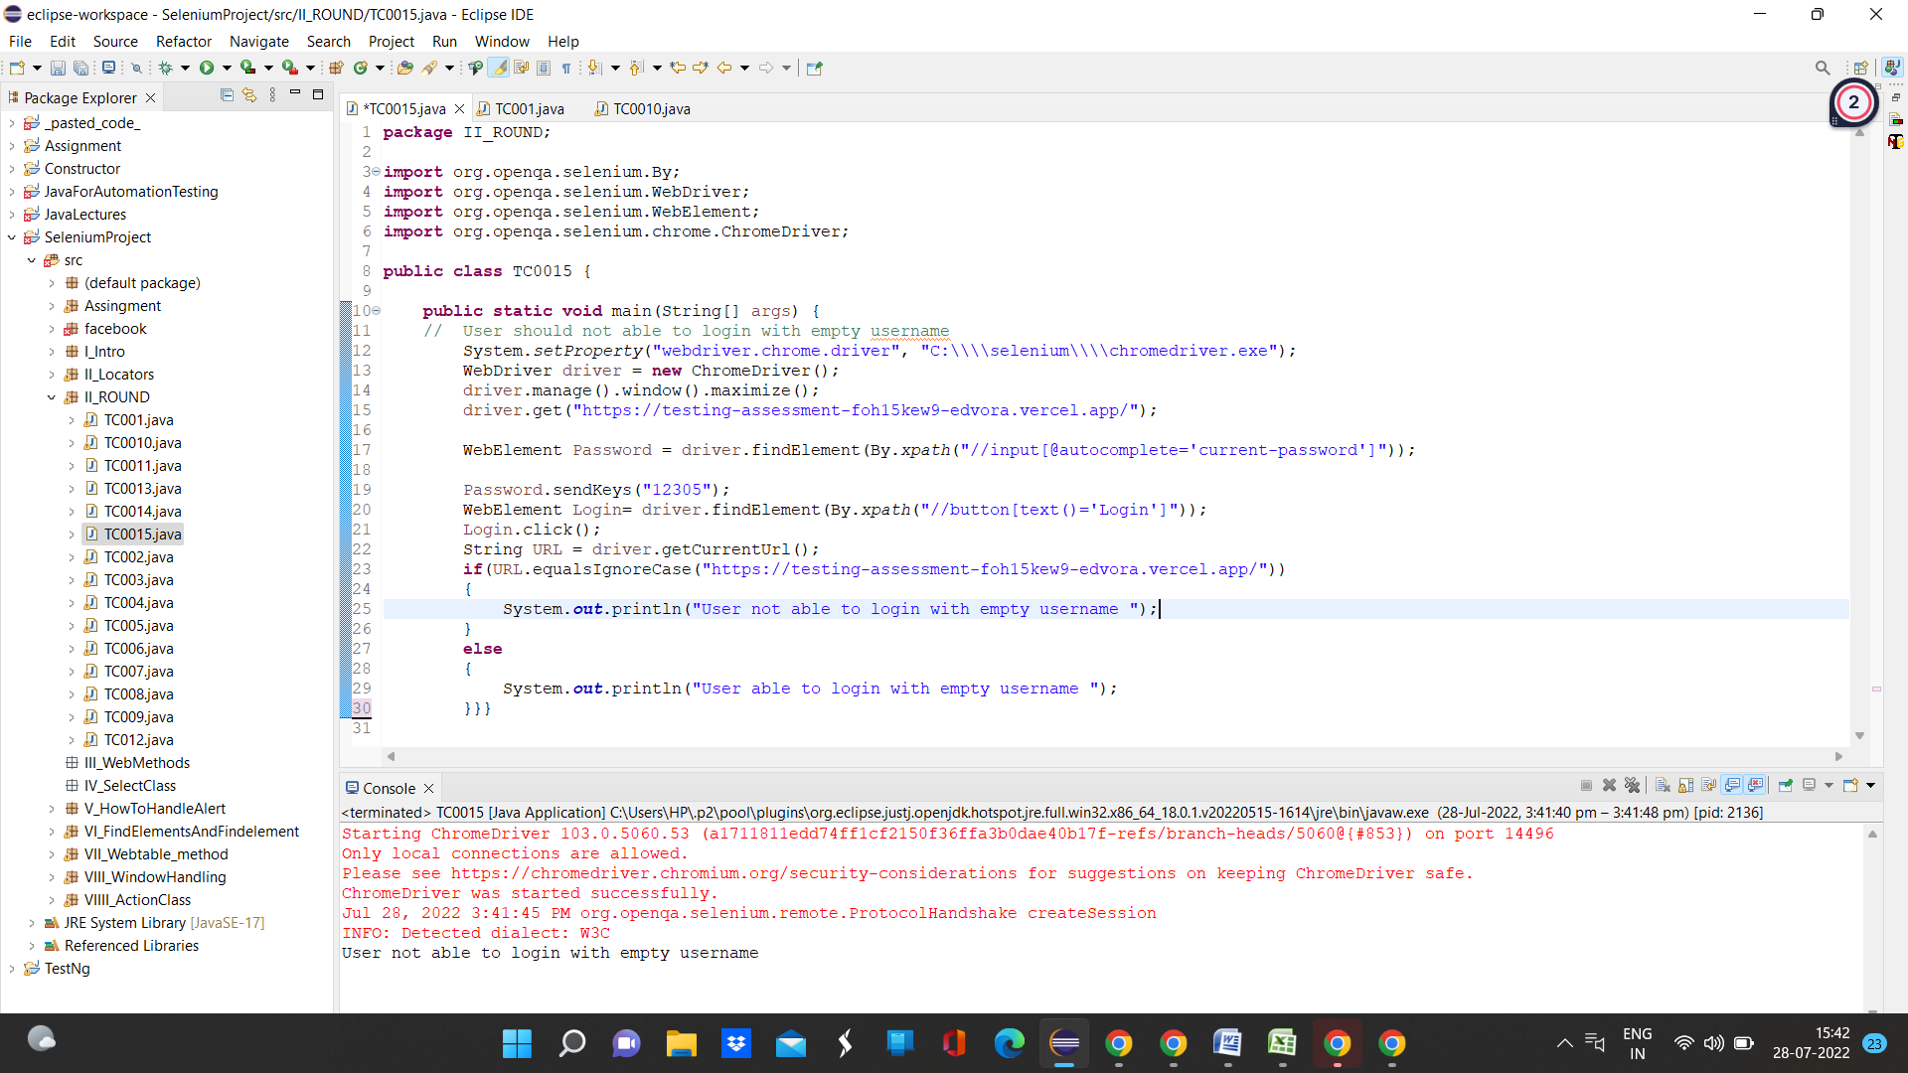

TC0016 User should not able to login with empty password

Status: Pass

Observed Result: User not able to login with empty password

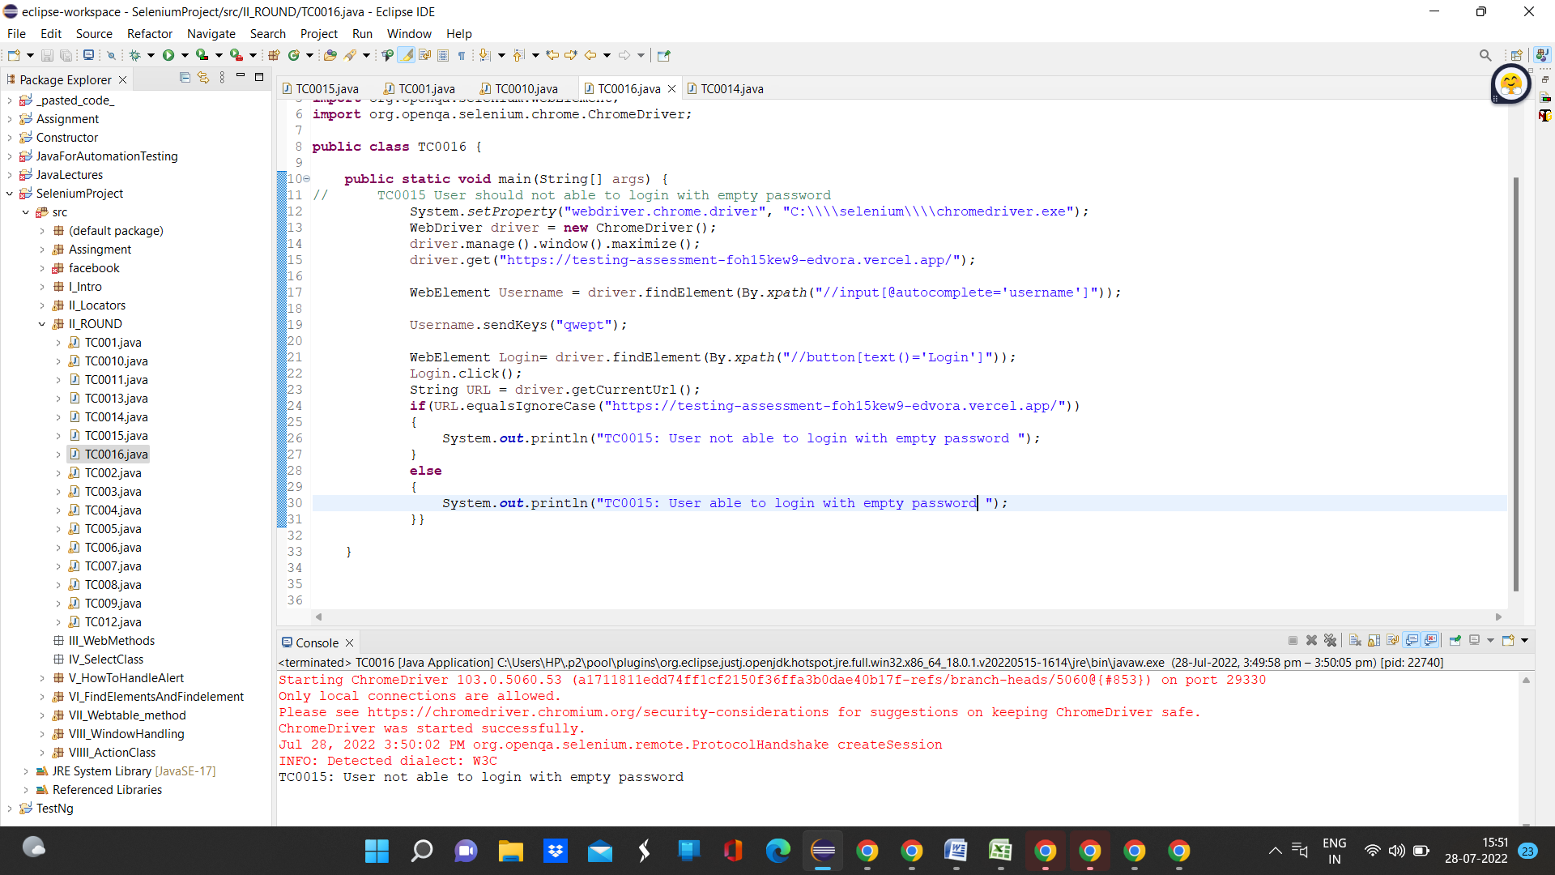

TC0017 User should not able to login with empty password and username

Status: Pass

Observed Result: User not able to login with empty password and username

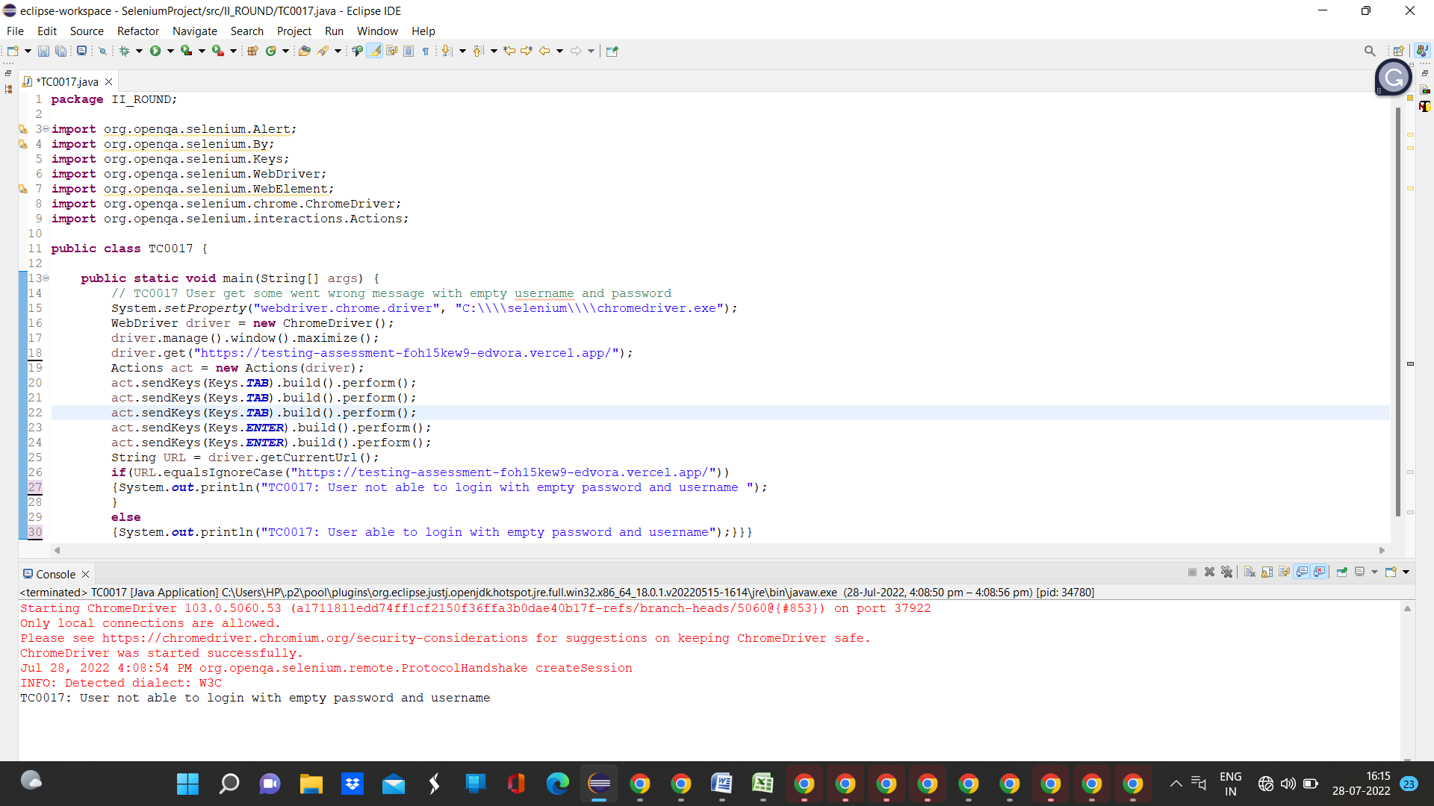

// TC0018 User should not able edit username on setting page

Observed result: User not able edit username on setting page

Status: Pass

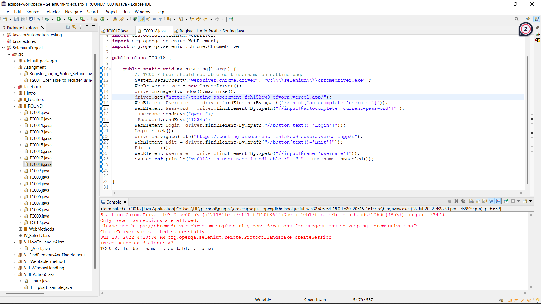

// TC0019 User should able to click on login button by using tab and enter button

Observer result: User able to click on login button by using tab and enter button

Status: Pass

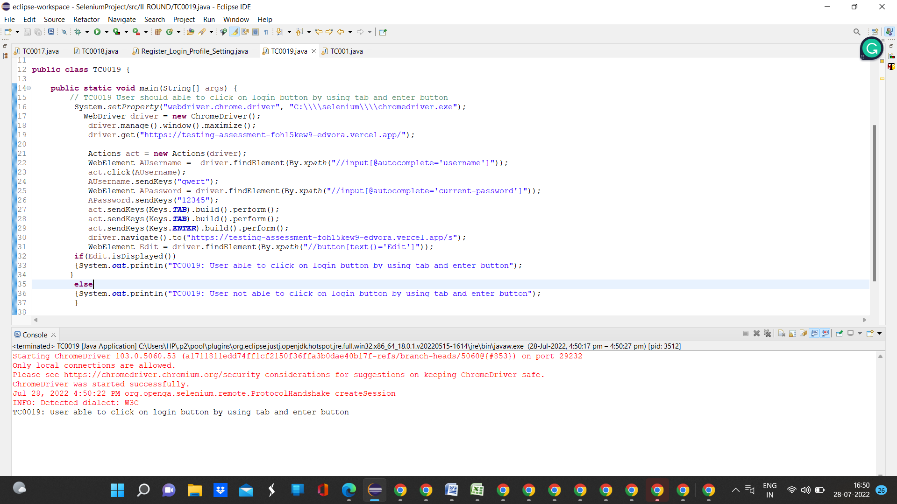

// TC0020: User should not create account with empty username and password

BUG09: user can create account with empty username and password

Steps:

1. Search Url in chrome driver
2. Click on SignIn button
3. Click on create account button

Observed result

user can create account with empty username and password and get Account created successfully message

Staus: Fail

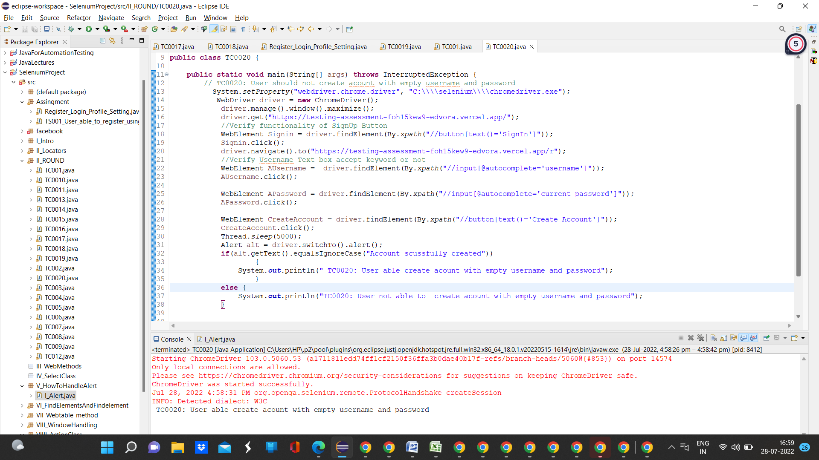

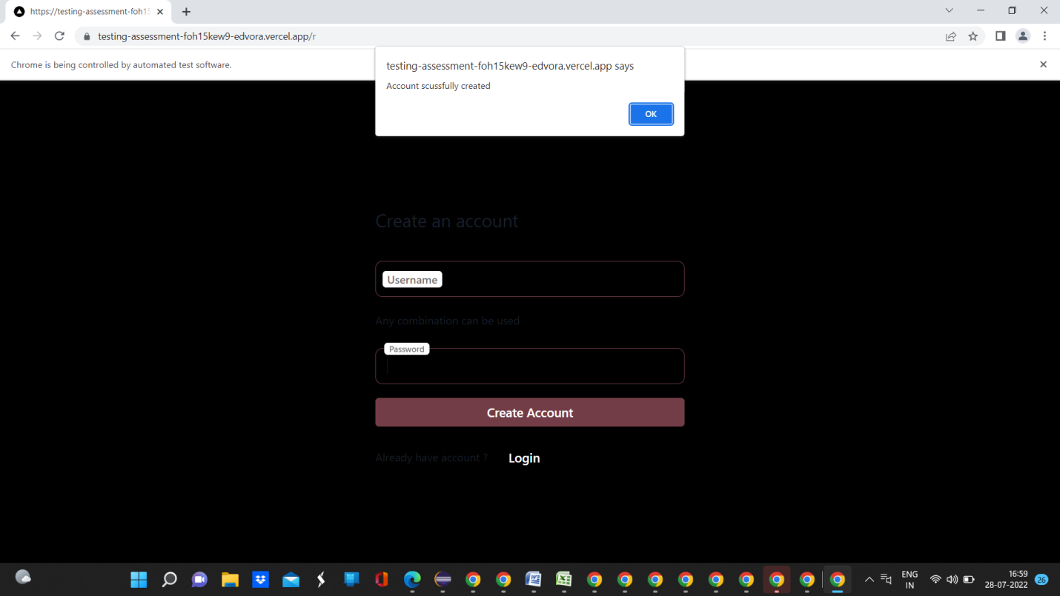

Expected Result: User should not able to create account with empty username and password filed

Priority: High

Severity: High